***On my honor, I pledge that I have not violated the provisions of the NJIT Student Honor Code***

STUDENT TEAM No__**2**__

Name Signature

…Arsh Bhamla………… ___**ARSH BHAMLA~~___~~**_ …Pranay KC………….. _**_PRANAY RAJ KC_____** ..Shreedhar Rajendran. **__Shreedhar Rajendran—**

..Christopher Karkenny. __**Christopher Karkenny**_

Experiment performed on date _05/ 07 / 2025__

Report submitted on date _________

Returned for corrections on date _________ Grade ______

Returned after corrections on date _________ Grade ______

**Introduction**

In this lab, we'll look at the applications of metal-oxide-semiconductor field-effect transistors (MOSFETs) and bipolar junction transistors. MOSFETs are commonly employed in modern digital circuits because they are very efficient and easily scalable as they operate by regulating voltage and have a high input impedance and BJTs use current control and are more prevalent in analog and high-power applications, where their signal amplification capabilities show brightly. We will mainly focus on an N-channel enhancement mode MOSFET and a NPN BJT, doing experiments to examine their switching, linear, and amplification properties. We will be looking at how a MOSFET’s extremely high gate impedance makes it useful as an analog switch, compared to the BJT’s current-driven design which will give us a better understanding of how these important components work and where they’re most useful.

**Procedure**

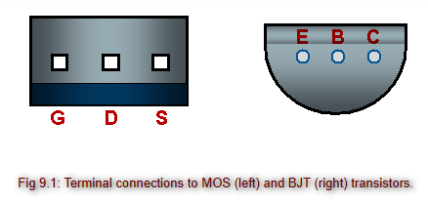

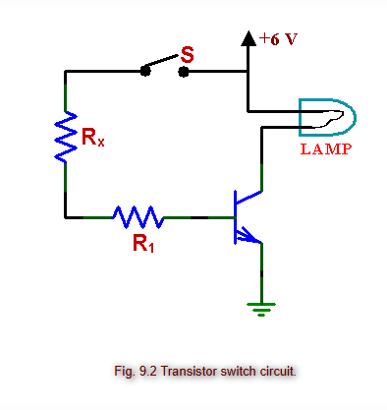

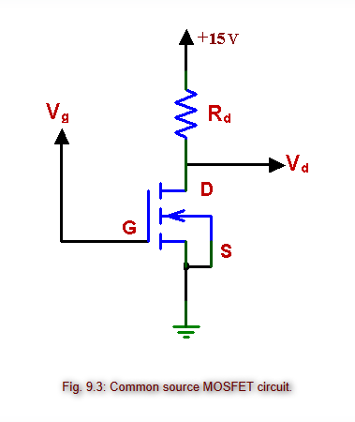

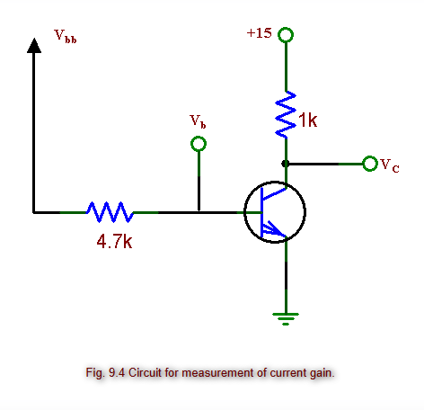

*Figure shown taken from* [*lab manual*](https://ecelabs.njit.edu/ece294/lab12.php)

**4.1 Polarity Of The Bipolar Transistor**

We will be checking the polarity of an npn Bipolar Junction Transistor (BJT) by first figuring out which terminals are the base, collector, and emitter and start by putting the ohmmeter’s positive lead on the base and the negative lead on the emitter. If the resistance is low, it means the junction is forward-biased, confirming the base is p-type and the emitter is n-type. We will then move the negative lead to the collector while keeping the positive lead on the base and a low resistance reading will confirm the p-type base and n-type collector junction. We will then put the negative lead on the base and the positive lead on the emitter or collector and should see high resistance readings, which indicate reverse-biased junctions. These measurements will confirm the npn setup of the transistor by showing the expected polarity of the base-emitter and base-collector junctions.

**4.2 Transistor As A Switch**

*4.2.1 BJT*

We will set up the circuit as shown in the lab manual and grab an npn BJT, a small incandescent lamp, a base resistor and a variable resistor (a resistance substitution box). We will connect the lamp in series with the collector and the positive power supply and wire up R1 and Rx in series between the base of the transistor and the power supply. We will set Rx to its maximum resistance value and slowly decrease it until the lamp lights up fully. We will then use an ammeter to measure the current through the lamp Ic and check the collector voltage Vc.

*4.2.2 MOSFET*

We will swap out the BJT for an N-channel enhancement mode MOSFET and connect the gate to Rx the source to ground, and the drain to the lamp, which is in series with the power supply. We will then disconnect Rx from both terminals and touch the free end of Rx with one hand while touching the positive supply or ground with the other. We will then ground the gate with our fingers to switch it "off," showing why it’s important not to leave the gate unconnected as its high impedance can cause unpredictable behavior. We will then measure the drain voltage Vd and lamp current Id when the lamp is "on." We will then compare how little current flows through the MOSFET gate to the larger base current required for a BJT.

*4.2.3 Switching Operation Of A MOSFET*

We will modify the MOSFET circuit by swapping out the lamp for two 100-ohm resistors connected in parallel from the drain to ground and connect a waveform generator to the gate using a 10 kohm resistor, and set it to output a square wave with enough amplitude to turn the MOSFET on and off and adjust the waveform generator's DC bias to make sure the output is unipolar, and double-check it using an oscilloscope. We will start with a frequency of 1 kHz, then gradually increase it while using a scope probe to observe the gate input and drain output signals. We will then take out the 10 kohm resistor and connect the gate directly to the waveform generator and keep increasing the frequency and measure the "turn on" and "turn off" times at both the input and output.

**4.3 Transistor As An Amplifier**

*4.3.1 MOSFET*

We will set up the circuit from Figure 9.3, use a 1 kohm drain resistor Rd with the source grounded and connect the drain to the power supply through Rd. We will start by applying a variable gate voltage Vg, beginning at 0 V and gradually increase Vg in small steps, and use a voltmeter to measure the drain voltage Vd at each step.

*4.3.2 BJT*

We will set up the circuit from Figure 9.4 and connect a 4.7 kohm base resistor and a 1 kohm collector resistor and use the base supply voltage to control the base current by adjusting it. For every base supply voltage value, measure both the base voltage and the collector voltage using a voltmeter.

**4.4 Transistor Characteristics**

To analyze both transistors we will use a curve tracer and set up the MOSFET in common-source mode and measure the drain current against the drain voltage for several gate voltages. For the BJT, we will configure it in common-emitter mode and measure the collector current against the collector voltage for different base currents. We will use voltage and current ranges that match the values used in Experiment 4.3 and draw the characteristic curves, making sure to label the axes with approximate scales.

**4.5 Mosfet As An Analog Switch**

We will build an analog switch circuit with an N-channel MOSFET and connect the source to a signal generator and the drain to a resistor that’s tied to ground and connect the gate to a control voltage using an SPDT switch. We will set the signal generator to output a waveform with a DC bias and use an oscilloscope to watch the drain output while flipping the switch between the control voltage and ground.

**Data and Calculations**

**4.1 Polarity Of The Bipolar Transistor**

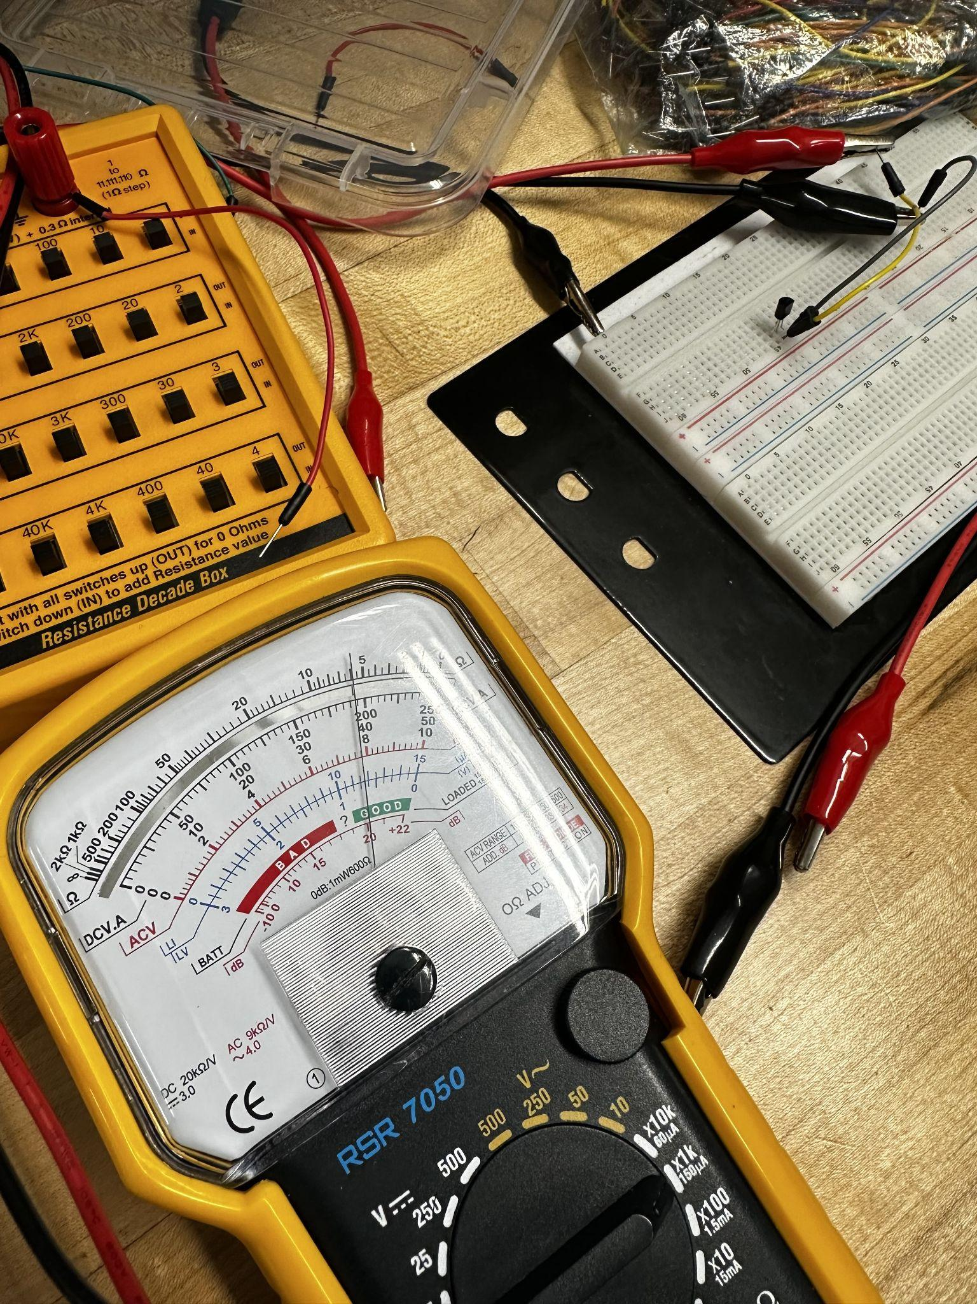

BJT B-E: 5.2k

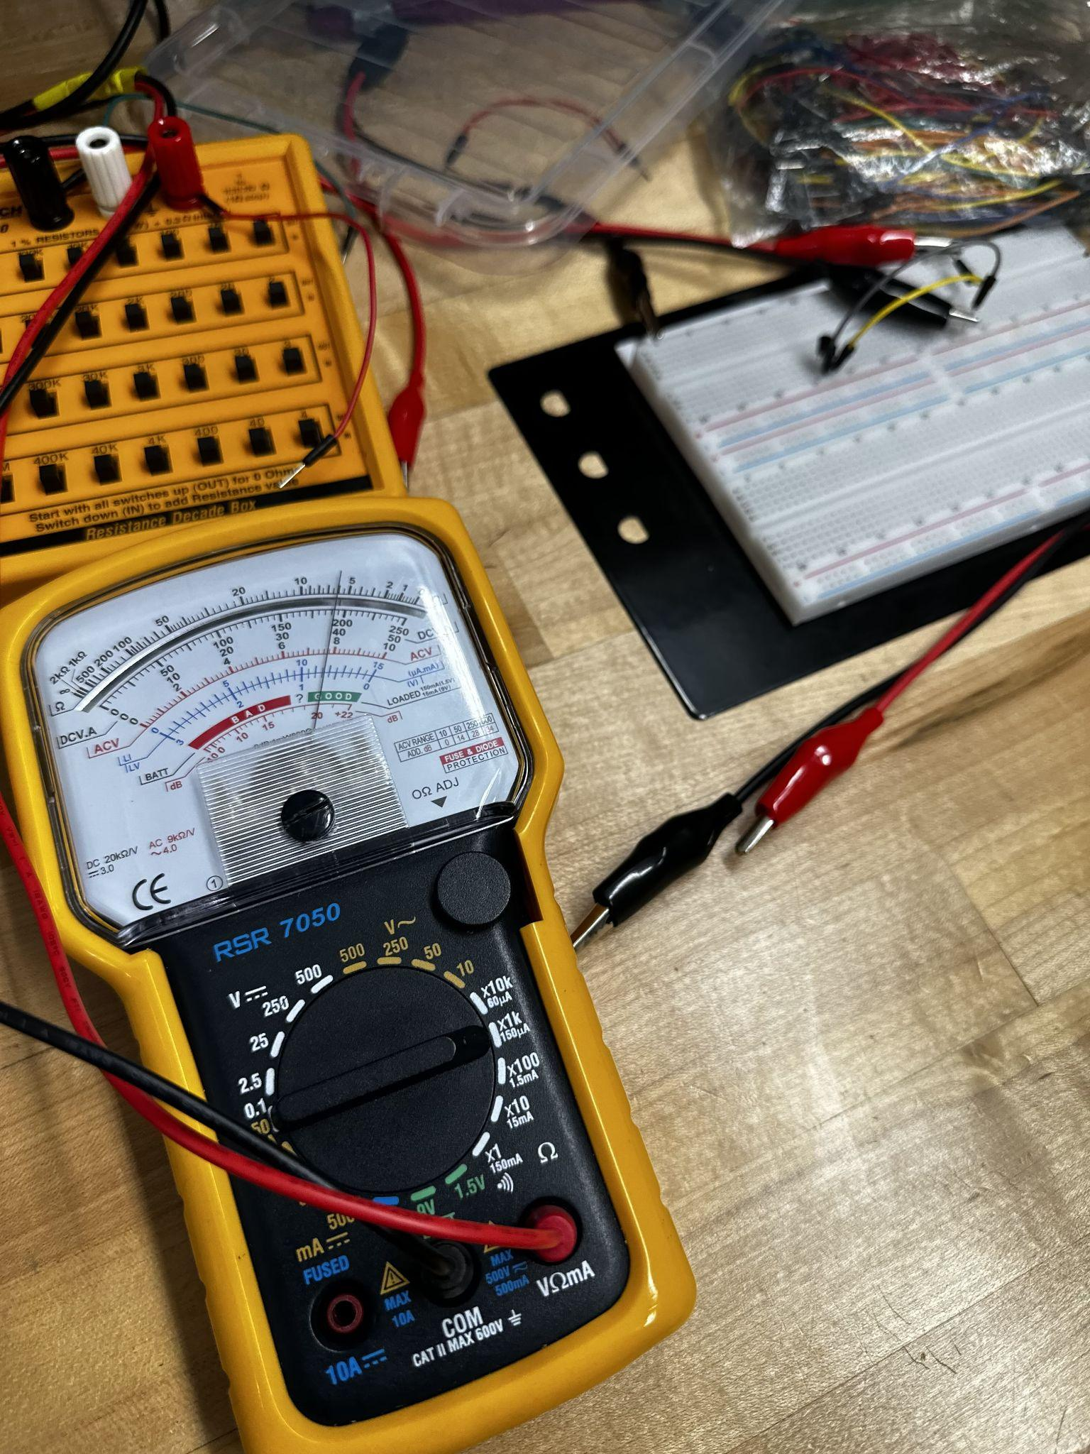

BJT B-C: 5.1k (Red in base, ground in collector)

Both = infinity when Red in E/C, ground in base

**4.2 Transistor As A Switch**

*4.2.1 BJT*

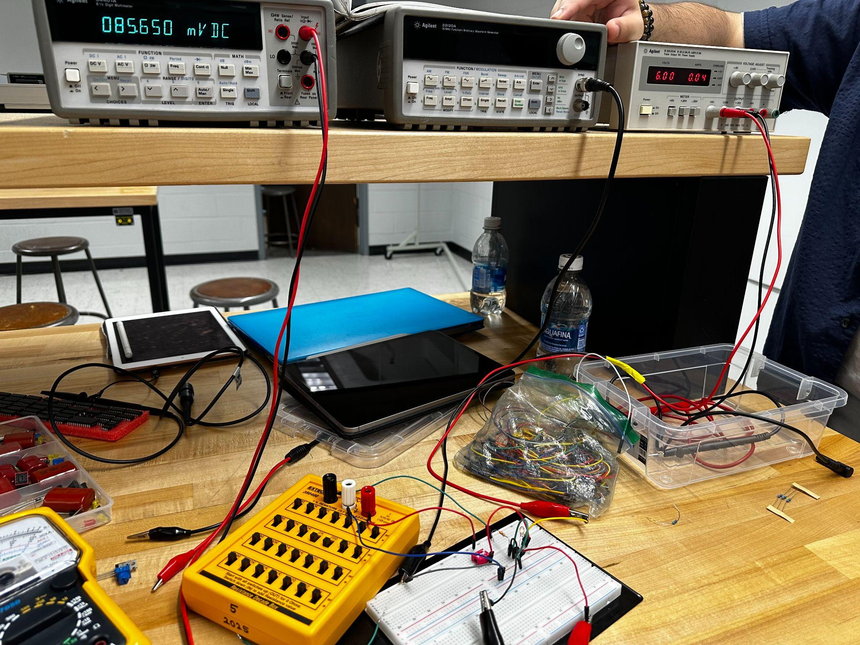

VB= 5.98, Rx=2.2k

RCE=0.67kohm, RBE= 12k

ILamp=29.1mA

Vc=85.7mV

*4.2.2 MOSFET*

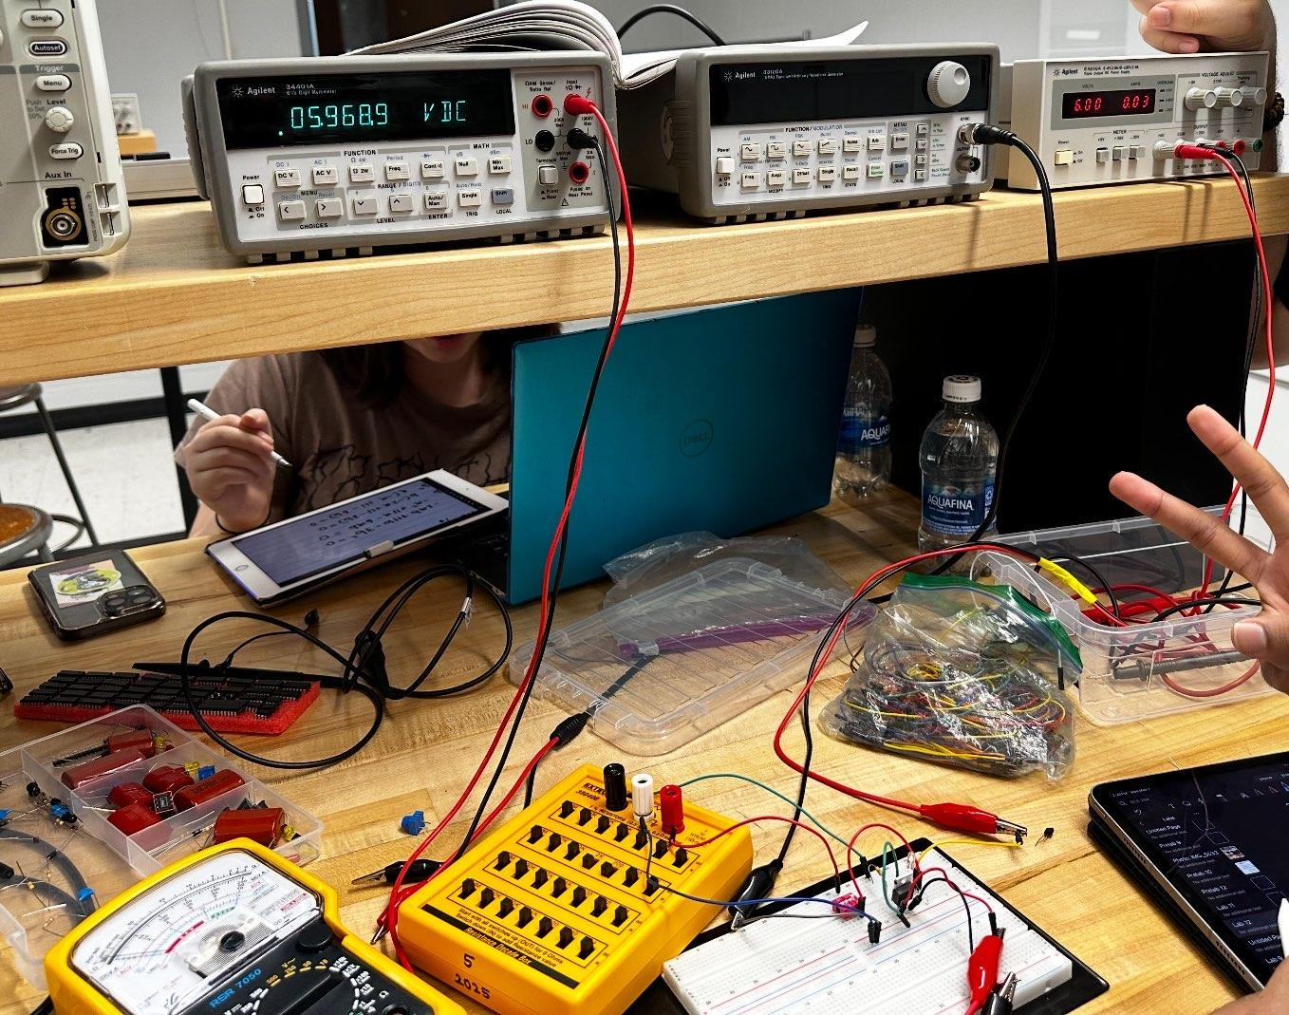

Vgs= 5.95V, Rx=2.2k

Output resistance = 33 ohms

Vds = 2.720mV

ILamp= 29.1mA

The mosfet needs less current to the transistor than compared to the BJT

*4.2.3 Switching Operation Of A MOSFET*

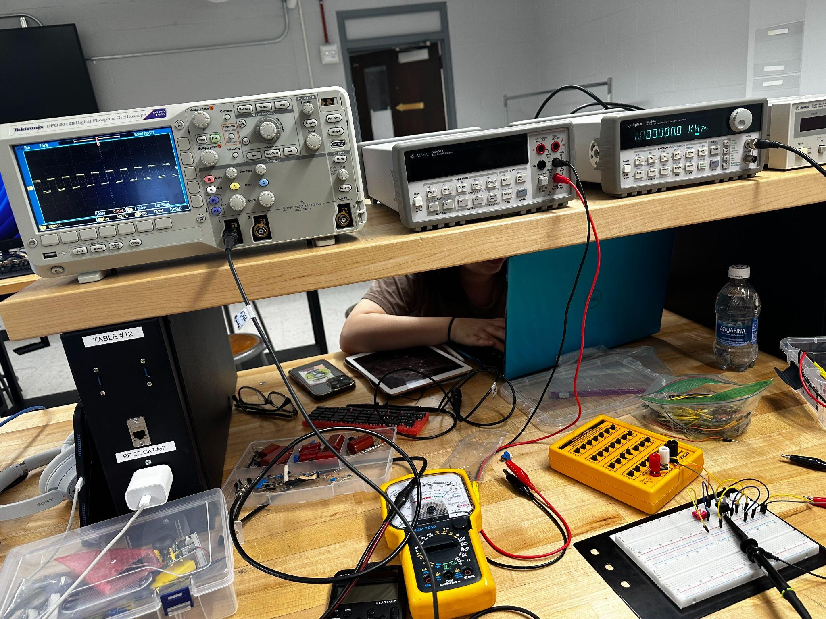

As shown above, this is the gate voltage

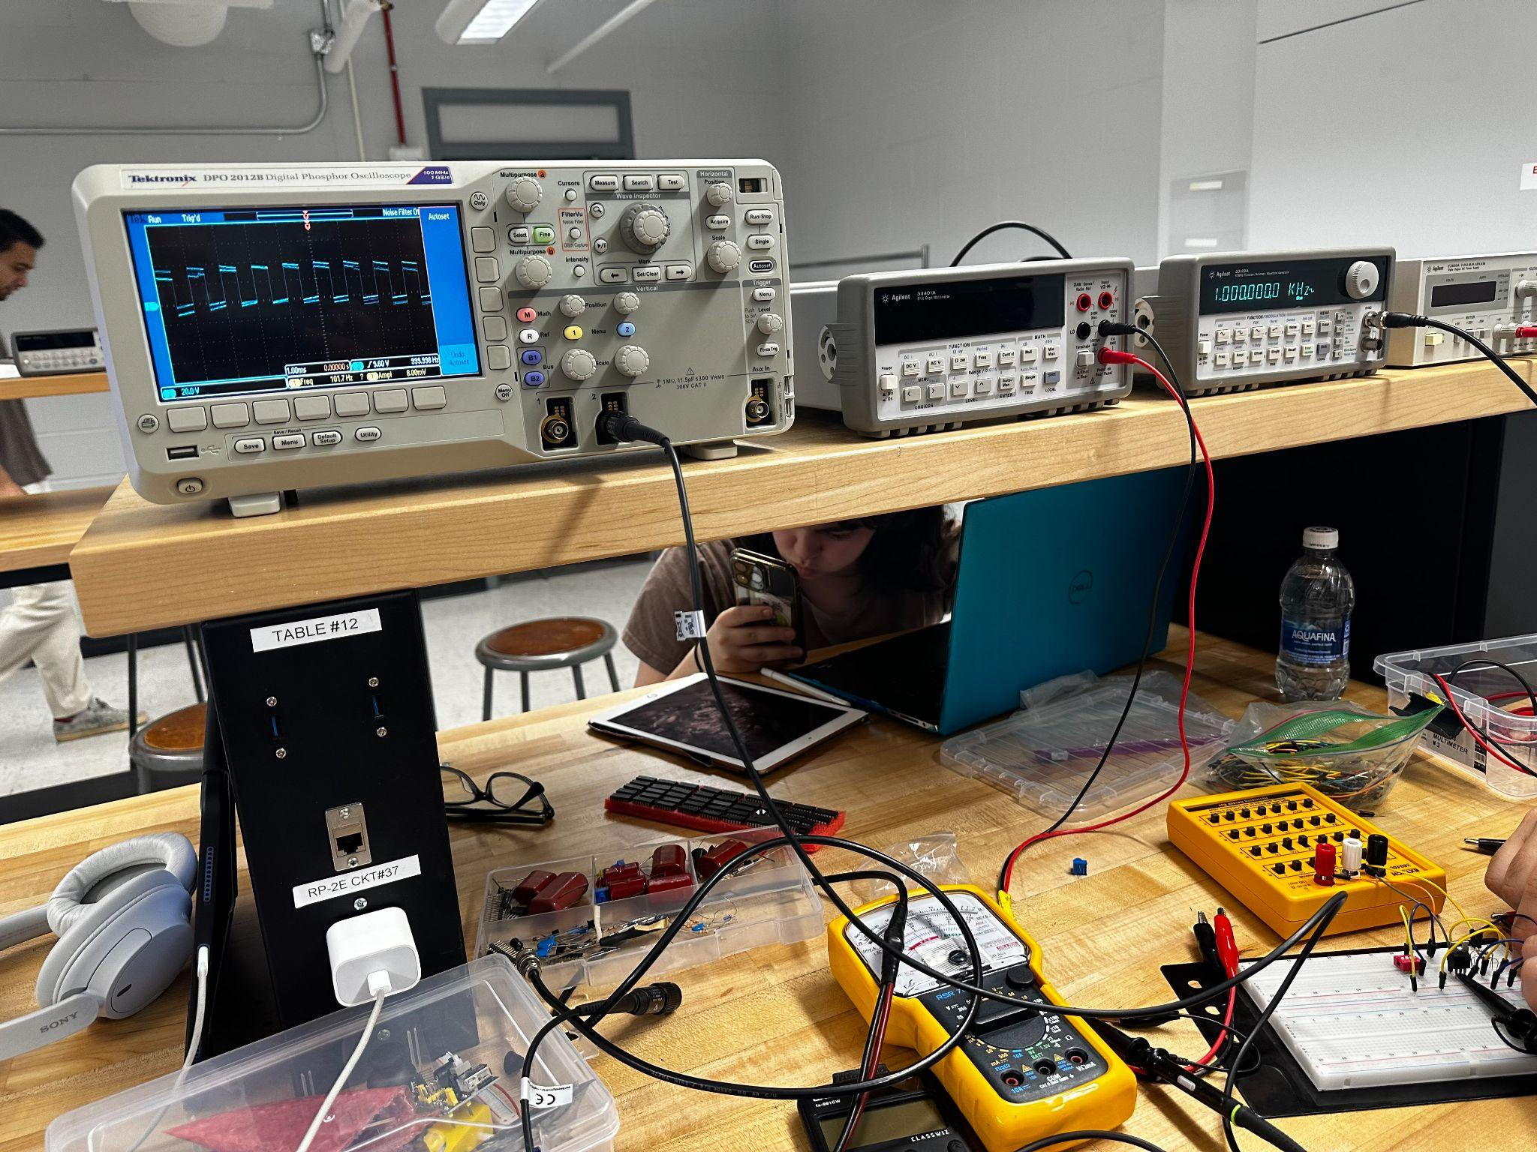

As shown above, this is the drain voltage.

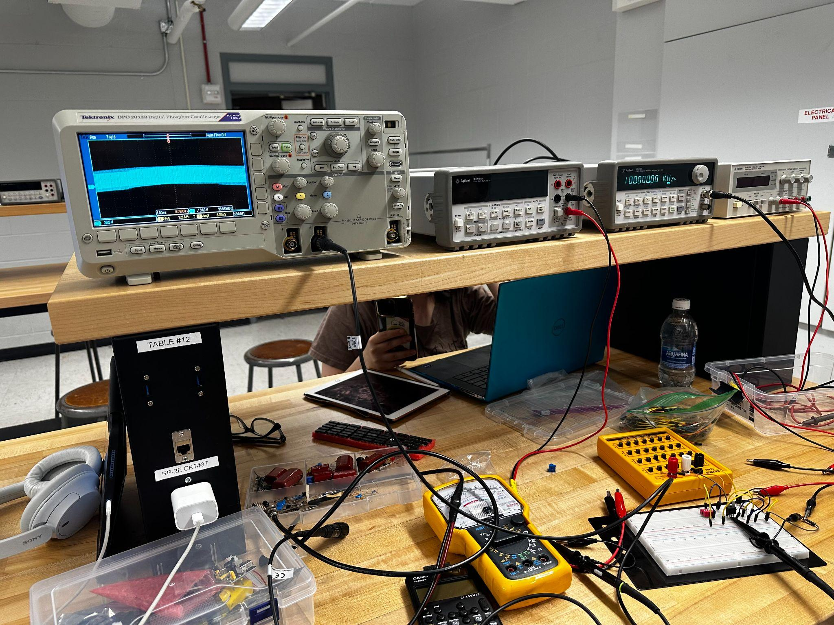

As shown above, this is limiting switching speed. The values of high and low blend together.

**4.3 Transistor As An Amplifier**

*4.3.1 MOSFET*

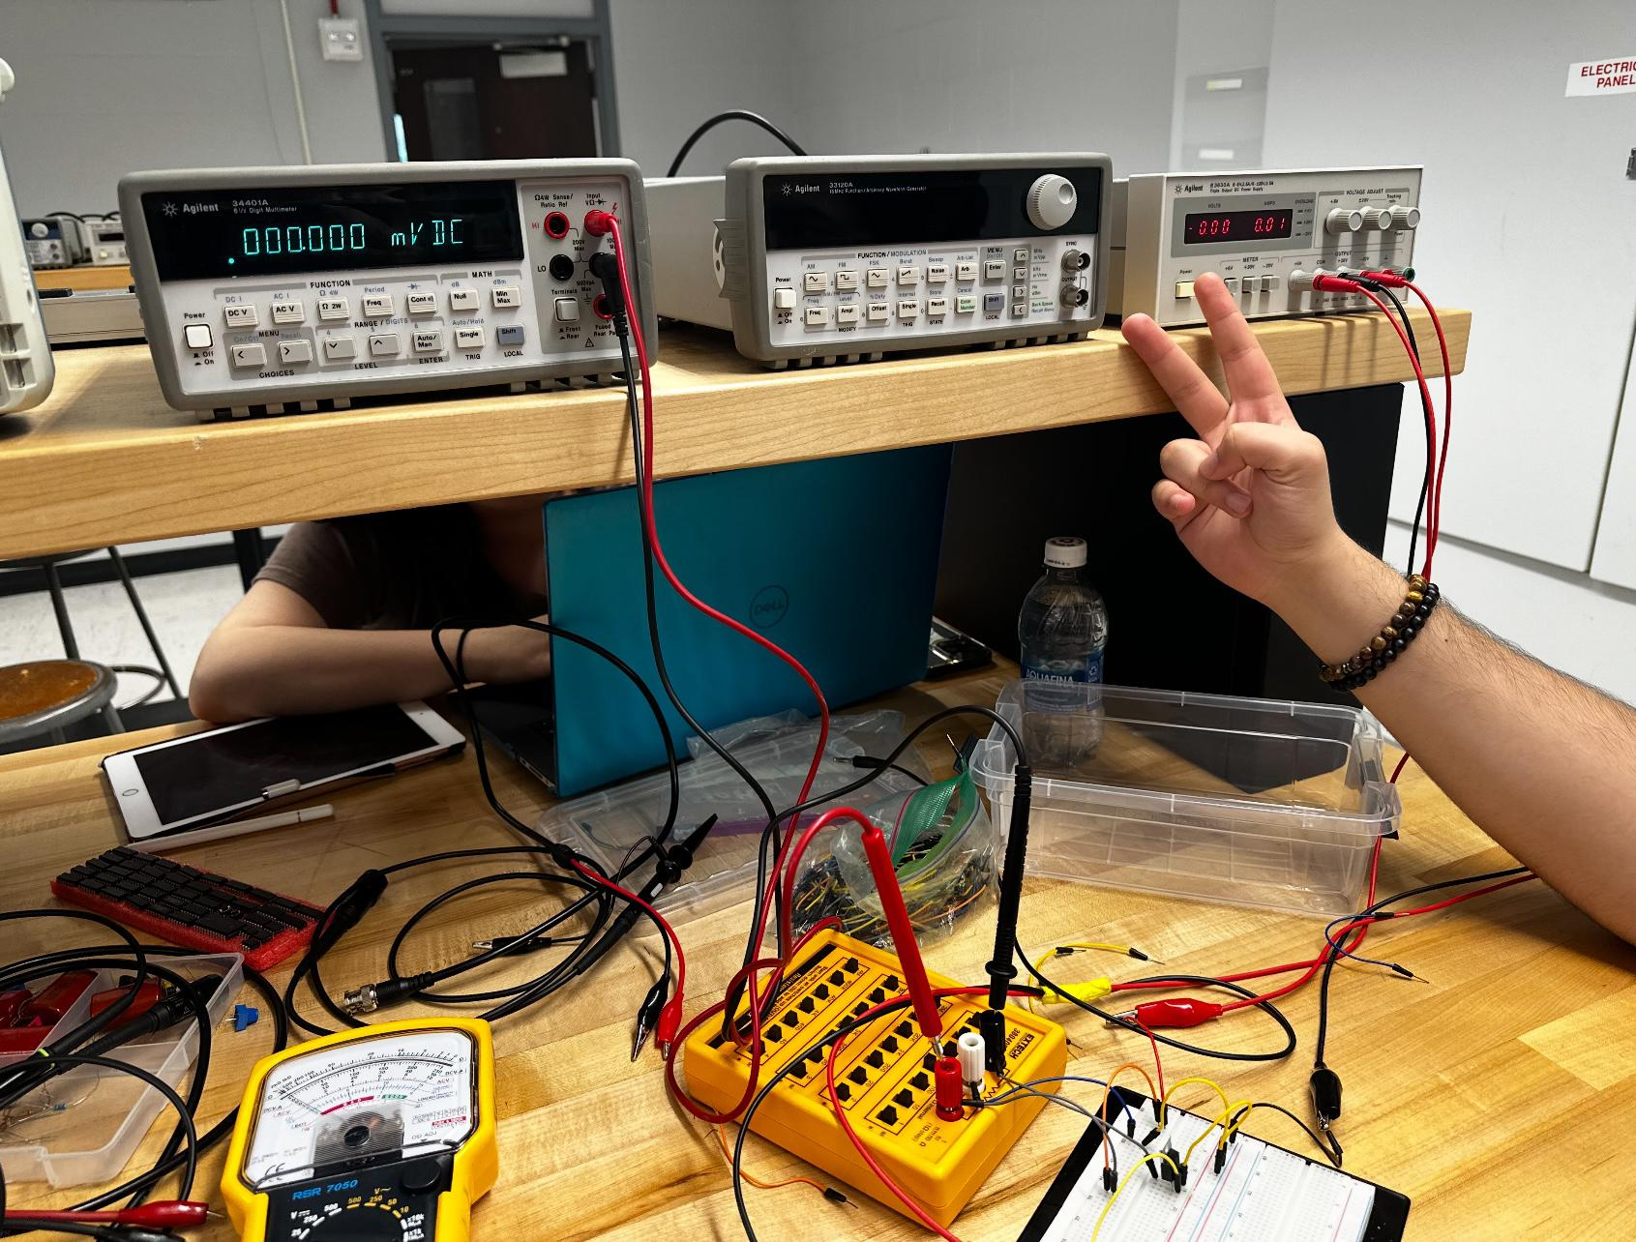

As shown below, at 2V it lets most of the voltage drop over the resistor.

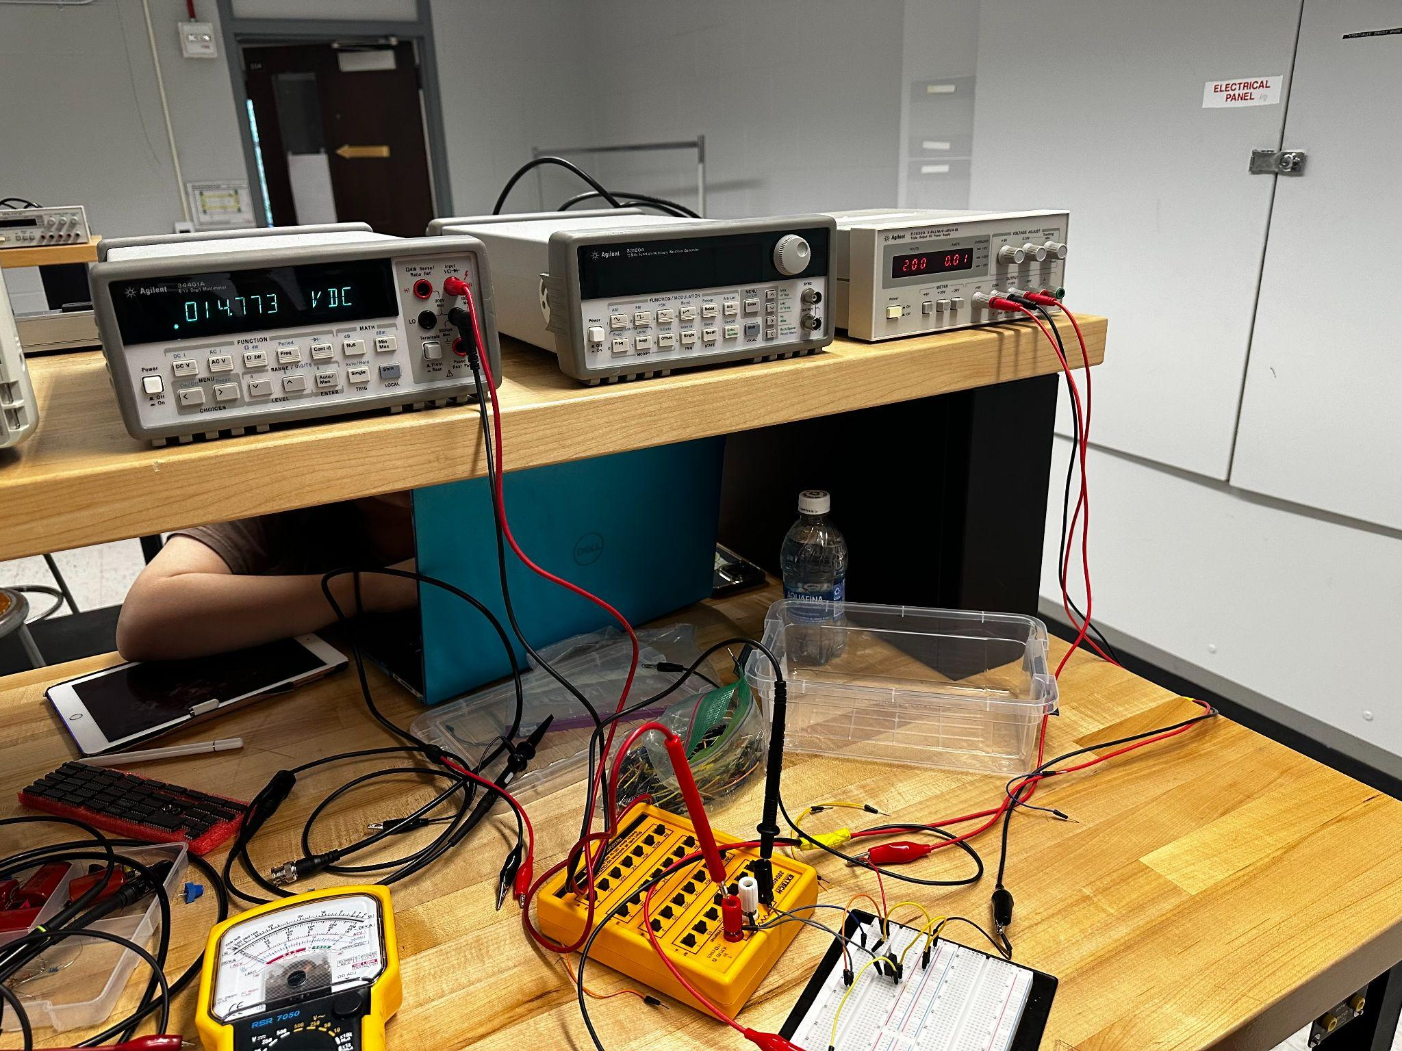

*4.3.2 BJT*

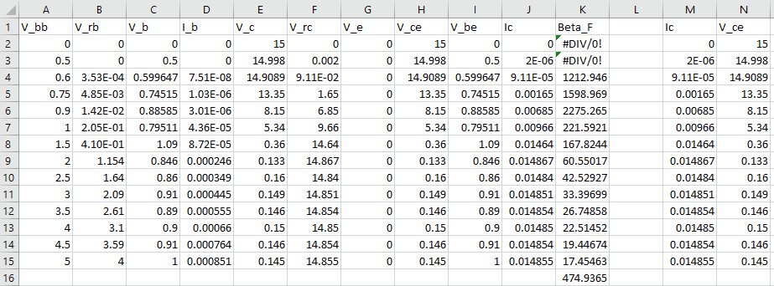

Average BetaF = 474.9365

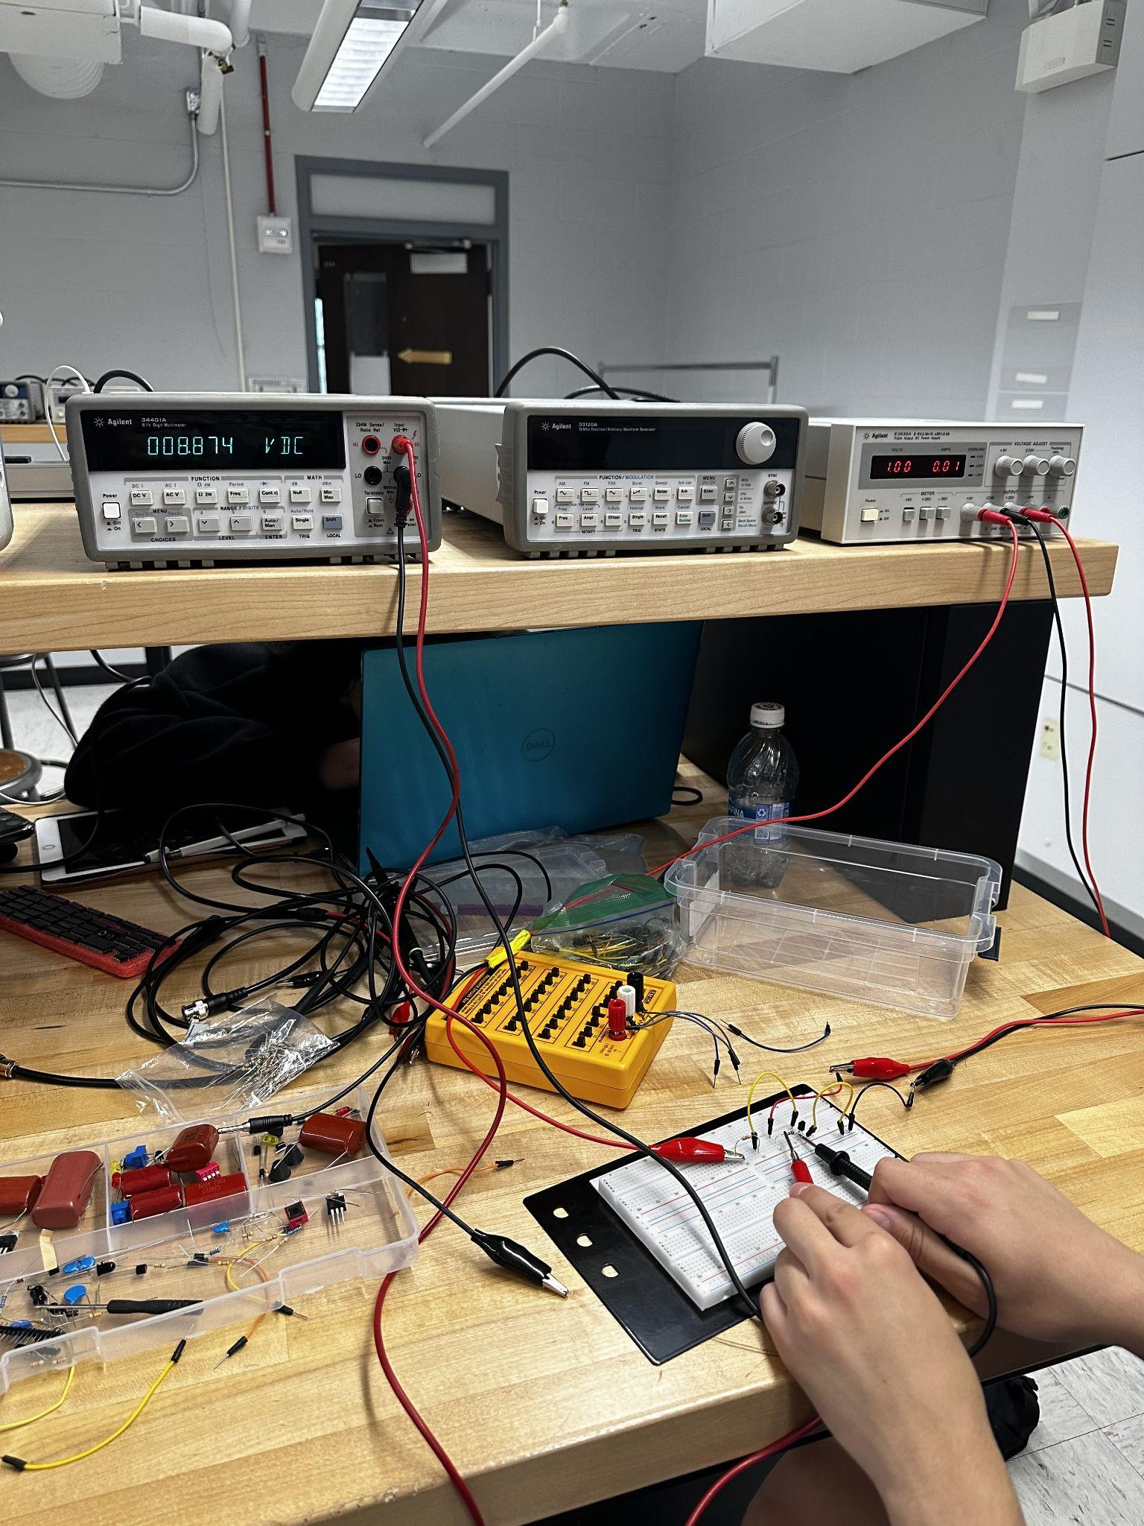

**4.4 Transistor Characteristics**

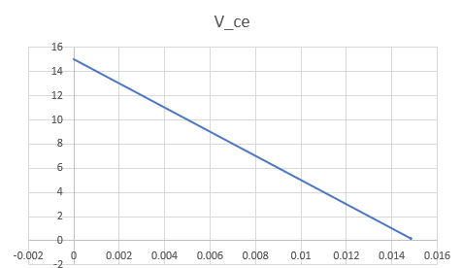

This graph represents the characteristic graph of the function. The problem we faced in making it a true IV curve is the limited amount of data points which are being used, which means that the graph’s movement looks very linear. In actuality, it more accurately looks like a decaying exponential function. We used the same data set found in 4.3.2 using Excel.

**Discussion**

The experiments in this lab show the key differences between MOSFETs and BJTs, especially when it comes to how they work and where they’re useful in real life. MOSFETs are voltage-controlled devices with super high input impedance, meaning they barely need any gate current, which makes them great for energy-efficient digital circuits while BJTs are current-controlled devices that rely on a noticeable base current for their amplification, making them super useful in analog and high-power setups. When we tested their switching abilities, MOSFETs stood out by handling large currents with very little input power, while BJTs needed more careful control of base current to get similar results as well as the amplification tests showed how MOSFETs respond predictably to gate voltage, while BJTs depend on their current gain which is really important for signal amplification but can be inconsistent. Also, MOSFETs were great as analog switches because they’re voltage driven, a feature that doesn’t work as well for BJTs since they’re dependent on current.

**Conclusions**

This lab helped us get a better understanding of MOSFET and BJT transistors and through the hands-on experiments we looked at the MOSFET’s high input impedance and how it works with voltage, compared to the BJT’s current-driven behavior and strong amplification abilities. These activities made it easier to connect the theory we’ve learned with real-world results as it shows the differences in switching, amplification, and how signals are handled and understanding these features is really important since it helps decide when to use each type of transistor being that MOSFETs work best for compact, energy-efficient digital systems, while BJTs are great for accurate analog and high-power applications. This lab not only strengthened our knowledge of how transistors work but also gave us useful insights into applying them in real electronic projects.